How to Access your 1095-C

Citrus County School Board is required to report certain information regarding the cost of your benefits to you and the IRS under the Affordable Care Act (ACA). Form 1095-C is used to report that information. Follow these instructions to download the form for your records.

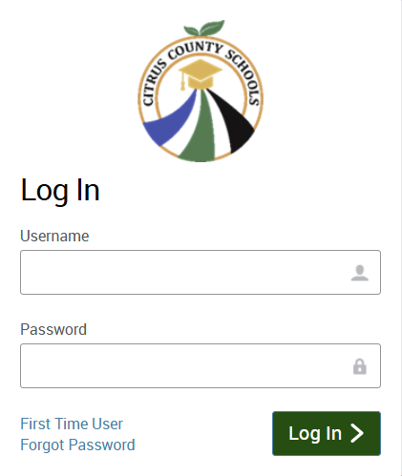
Step 1
You can log into bswift directly through CCSB’s Employee Benefit Portal and visit the Enrollment Center or by downloading the bswift app.

Username: Your Date of Birth (MMDDYYYY) + Last 4 digits of your Social Security Number. Example: 010119001234

Password: Use the “Forgot Password” link if you do not remember your password from the Open Enrollment.

Step 2

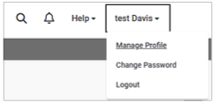
- Once logged in, select your full name in the top righthand corner of the screen with a drop-down arrow.

- Select “Manage Profile.”

- Under “Manage Documents”, click “View All Documents.”
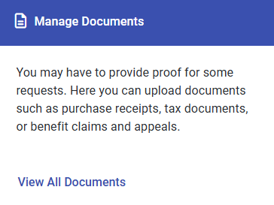
- Scroll down the page until you see the document titled “[Your Name] 2025 1095-C.”

- Select “View” on the right side of the row and your statement will download.

- Once downloaded, you are able to print the 1095-C.

